
Investigating the Association Between Cardiovascular Health Indicators and Individual Characteristics
By Weiyi Huang, Aaron Niecestro, Yuzhou Pan, Alison Stephens

May 11, 2025
University Of Texas Health Science Center at Houston
Applied Multivariate Data Analysis

Introduction

Cardiovascular and metabolic health are influenced by a complex interplay of demographic and physiological factors. Understanding how variables such as age, gender, body mass index (BMI), and hypertension status jointly and independently affect vital health indicators—such as pulse rate, blood pressure, and glucose levels—is critical for advancing personalized medicine and improving population health outcomes. This study aims to investigate how these factors predict key health indicators and interact to shape overall metabolic regulation. By analyzing these relationships, we can identify which factors contribute most significantly to health risks and how they might be used to inform more accurate, individualized prevention and treatment strategies. Additionally, by examining multiple factors simultaneously, we seek control for confounding influences and draw more precise conclusions about the drivers of cardiovascular and metabolic health.

Description of the Data

The dataset analyzed in this study contains health-related information from 5,437 adult patients and includes 14 independent variables encompassing demographic details, clinical measurements, and medical history. Data collection was conducted by researchers from United International University and Southeast University in Bangladesh. To ensure data quality and relevance, preprocessing steps were applied to focus solely on adult participants and to exclude physiologically implausible or emergency medical values. Specifically, records were retained only if body mass index (BMI) ranged between 15 and 55, pulse rate was at least 40 beats per minute (reflecting healthy athletic baselines), systolic blood pressure did not exceed 210 mmHg (avoiding hypertensive crisis), and glucose levels ranged between 4.0 and 13.3 mmol/L to exclude cases requiring urgent clinical intervention. These cleaning criteria ensured the dataset reflected a population suitable for general cardiovascular and metabolic health analysis.

Data Transformation

Because many multivariate statistical methods rely on the assumption of normality, the response variables—pulse rate, systolic blood pressure (SBP), diastolic blood pressure (DBP), and glucose levels—were evaluated and transformed to better approximate normal distributions. The Box-Cox transformation method was applied to each of these variables, yielding transformation parameters of approximately 0.167 for pulse rate, -0.562 for glucose, -0.589 for SBP, and 0.029 for DBP. These transformations were implemented using R’s boxcox function and were chosen to improve the statistical validity of subsequent analyses. While transformation enhanced the normality of each variable to some extent, perfect multivariate normality was not achieved. Nonetheless, the transformed data were deemed suitable for further modeling and hypothesis testing under the assumption of approximate normality.

Statistical Methods

To address the research questions, a suite of multivariate statistical techniques was employed. First, a one-sample Hotelling’s T² test was used to evaluate whether the sample’s mean vector of health measurements significantly differed from a hypothesized population mean vector. This test was performed both on the four core response variables and on a five-variable vector including age. In both cases, the null hypothesis was rejected, indicating that the observed means were significantly different from the reference population. Following this, one-way and two-way multivariate analyses of variance (MANOVA) were conducted to examine the effects of BMI, gender, and hypertension status on the combined health outcomes. The one-way MANOVA results showed statistically significant differences in the response variables across each of these categorical factors. The two-way MANOVA allowed for the exploration of joint and interaction effects, providing more nuanced insights into how these predictors interact.
To further account for the continuous influence of age as a covariate, multivariate analysis of covariance (MANCOVA) was applied. This method helped isolate the effects of BMI, gender, and hypertension status while statistically controlling for the effect of age. Post-hoc analyses using confidence intervals were conducted to pinpoint which groups differed significantly on each individual response variable. Finally, multivariate linear regression models were developed to quantify the relationships between predictors and health outcomes. Two nested models were compared: one including age, gender, and BMI, and a second incorporating hypertension status. The full model demonstrated superior fit based on AIC criteria and a statistically significant likelihood ratio test, confirming that hypertension status contributes meaningfully to the prediction of health outcomes.

Results

The results of the analyses consistently indicated that BMI, hypertension status, gender, and age play significant roles in predicting cardiovascular and metabolic health indicators. In the one-way MANOVA analyses, each categorical variable—BMI, gender, and hypertension—was found to significantly influence the response variables. Notably, higher BMI categories (overweight and obese) were associated with elevated blood pressure and glucose levels, consistent with existing clinical literature. Gender differences were most pronounced in pulse rate, with males generally exhibiting higher values. Hypertension status emerged as a particularly strong predictor of both systolic and diastolic blood pressure, as well as glucose levels.
The two-way MANOVA models reinforced these findings. BMI remained a significant predictor of blood pressure levels, while gender effects persisted for pulse rate and diastolic blood pressure. However, interaction effects between gender and BMI, as well as between hypertension status and gender, were not statistically significant, suggesting that these predictors operate largely independently rather than synergistically. The MANCOVA analyses confirmed that age had a confounding influence on the relationships between categorical predictors and health outcomes. For example, when age was included as a covariate, it significantly affected the confidence intervals associated with group differences by BMI, gender, and hypertension status.
In the multivariate linear regression analysis, the model that included all four predictors—age, gender, BMI, and hypertension status—was found to be the best-fitting model, with the lowest AIC value and statistically significant model comparison results. This model explained a substantial portion of the variability in the transformed health outcomes and provided a robust framework for understanding how these individual characteristics jointly influence cardiovascular and metabolic regulation.

Conclusion

This study highlights the significant roles played by BMI, hypertension status, gender, and age in shaping cardiovascular and metabolic health indicators. Overweight and obesity were strongly associated with higher blood pressure and glucose levels, while males exhibited higher pulse rates compared to females. Hypertension status had a broad and consistent impact across blood pressure and glucose variables, reinforcing its importance as a health risk factor. Age emerged as a key confounding variable, influencing the interpretation of group differences and underlying the necessity of adjusting for it in multivariate models. While the study provides meaningful insights, it also emphasizes the complexity of modeling physiological outcomes influenced by multiple interrelated factors.

Limitations

Despite the robustness of the statistical methods used, several limitations constrain the generalizability of the findings. Most notably, the dataset lacks detailed documentation about the original data collection methods. Without knowledge of whether the data were derived from medical records, surveys, or clinical measurements, questions about data reliability remain. Furthermore, the study design is observational and cross-sectional, preventing causal inference. Another limitation stems from the restricted number of predictors available; although four continuous response variables were analyzed, the predictor set was relatively narrow. Additionally, although 303 outliers were identified using Mahalanobis distance thresholds, they were not removed due to concerns about improperly excluding influential cases without sufficient justification.

Future Directions

Future research should focus on obtaining higher-quality datasets with clearer documentation of data collection procedures and a broader range of predictor variables. One potential improvement is to reduce the number of response variables by using a composite measure such as Mean Arterial Pressure (MAP) instead of analyzing systolic and diastolic blood pressure separately. Further post-hoc analyses may uncover more subtle group differences that were not evident in the primary analysis. Expanding the study to include data from multiple populations or healthcare centers would also help improve the generalizability of the findings. Finally, developing more rigorous criteria for identifying and managing influential outliers would strengthen the integrity of future statistical analyses.

References:

- Prama, Tabia Tanzin, et al. DiaHealth: A Bangladeshi Dataset for Type 2 Diabetes Prediction. Mendeley Data, V1 (2024), https://doi.org/10.17632/7M7555VGRN.1.
- Ramesh, Gautam et al. Associations Between Adherence to the Dietary Approaches To Stop Hypertension (Dash) Diet and Six Glucose Homeostasis Traits in the Microbiome and Insulin Longitudinal Evaluation Study (Miles). DigitalCommons@TMC. Print.
- Li, Shengxu et al. “BMI and Waist Circumference Are Associated with Impaired Glucose Metabolism and Type 2 Diabetes in Normal Weight Chinese Adults.” Journal of diabetes and its complications 28.4 (2014): 470–476. Web.
- Il’yasova, D et al. “Prospective Association between Fasting NEFA and Type 2 Diabetes: Impact of Post-Load Glucose.” Diabetologia 53.5 (2010): 866–874. Web.
- Branch, OraLee H et al. “Relationships Between Blood Pressure Reduction, Weight Loss, and Engagement in a Digital App–Based Hypertension Care Program: Observational Study.” JMIR formative research 6.10 (2022): e38215–e38215. Web.
- Ma, Jun et al. “Quantifying the Relationships of Blood Pressure with Weight, Height and Body Mass Index in Chinese Children and Adolescents.” Journal of paediatrics and child health 48.5 (2012): 413–418. Web.
- DRIVSHOLM, T et al. “Symptoms, Signs and Complications in Newly Diagnosed Type 2 Diabetic Patients, and Their Relationship to Glycaemia, Blood Pressure and Weight.” Diabetologia 48.2 (2005): 210–214. Web.
- Kahn, Linda G et al. “Evaluating the Relationship Between Birth Weight for Gestational Age and Adult Blood Pressure Using Participants From a Cohort of Same-Sex Siblings, Discordant on Birth Weight Percentile.” American journal of epidemiology 186.5 (2017): 550–554. Web.

Appendix

Table 1: Continuous Variables Summary Statistics of the Original Data

Variable | Min | Max | Mean | Standard Deviation
Pulse Rate (bpm) |  |  | 76.49 | 12.02
Glucose (mg/dL or mmol/L) |  |  | 7.123 | 1.64
Systolic Blood Pressure (mmHg) |  |  | 133.4 | 21.92
Diastolic Blood Pressure (mmHg) |  |  | 81.89 | 12.44
Age (Years) |  |  | 45.33 | 14.13

Table 2: Categorical Variables Summary Statistics

Variable | Count (n = 5046)
Gender: Male | 1486
Gender: Female | 3560
Hypertension: Yes | 516
Hypertension: No | 4530
Underweight (15 ≤ BMI < 18.5) | 722
Healthy (18.5 ≤ BMI < 25) | 3276
Overweight (25 ≤ BMI < 30) | 827

Figure 1: Multivariate Normality Plot of Original vs Transformed Data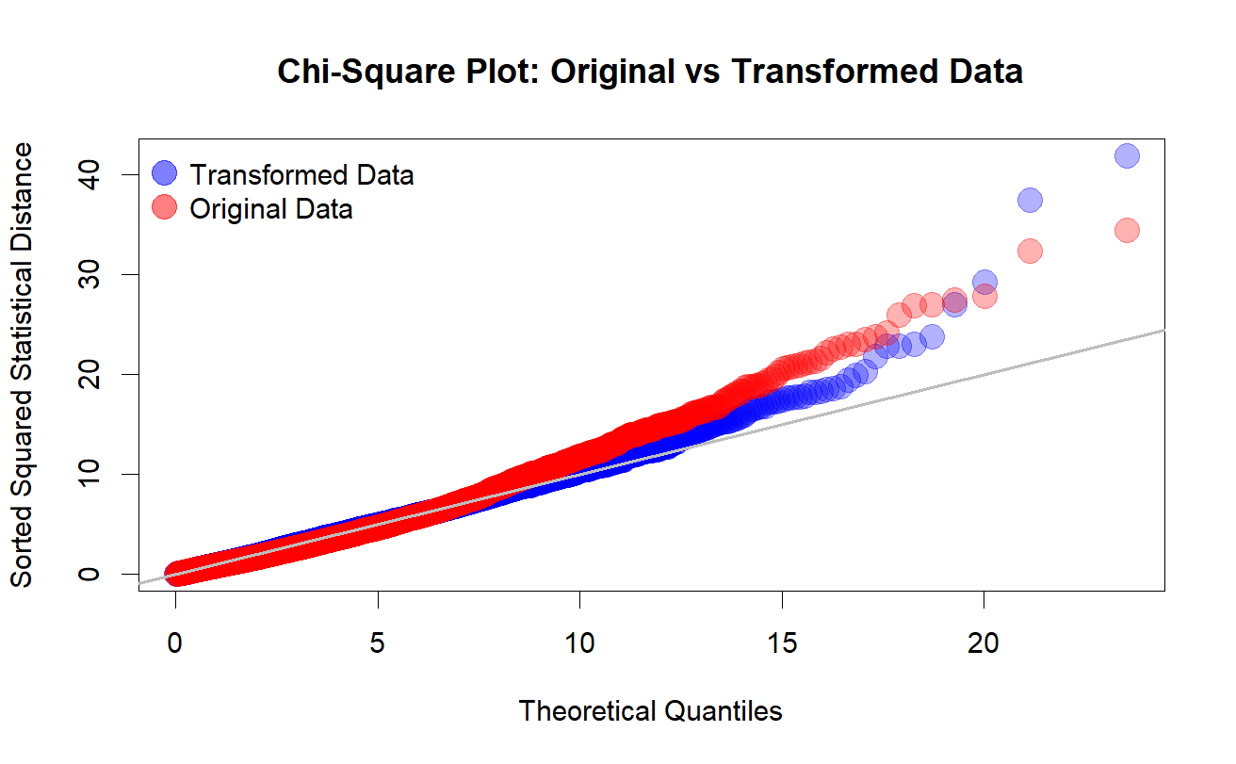
Table 3: Continuous Variables Summary Statistics of the Transformed Data

Variable | Min | Max | Mean | Standard Deviation
Pulse Rate (bpm) |  |  | 6.34 | 0.31
Glucose (mg/dL or mmol/L) |  |  | 1.18 | 0.07
Systolic Blood Pressure (mmHg) |  |  | 1.60 | 0.01
Diastolic Blood Pressure (mmHg) |  |  | 4.69 | 0.17

Table 4: One-Sampling Hotelling T² Confidence Intervals

Variable | T² Confidence Intervals: | Bonferroni-Corrected Confidence Intervals:
Transformed Pulse Rate | (6.325, 6.355) | (6.328, 6.351)
Transformed SBP | (1.601, 1.601) | (1.601, 1.601)
Transformed DBP | (4.679, 4.695) | (4.681, 4.693)
Transformed Glucose | (1.173, 1.80) | (1.174, 1.179)
Age | (44.665, 45.990) | (44.815, 45.840)

Table 5: One-Way MANOVA for BMI Categories

 | Pulse Rate | Systolic BP | Diastolic BP | Glucose
Healthy vs Obese | (-0.035, 0.0217) | (-0.1086, -0.0501) | (-0.1253, -0.0709) | (-0.0437, 0.0371)
Healthy vs Overweight | (-0.0303, 0.0014) | (-0.057, -0.0243) | (-0.0748, -0.0444) | (-0.0474, -0.0023)
Healthy vs Underweight | (-0.0225, 0.011) | (-0.007, 0.0275) | (0.0162, 0.0482) | (-0.023, 0.0245)
Obese vs Overweight | (-0.0387, 0.023) | (0.007, 0.0705) | (0.0089, 0.0681) | (-0.0654, 0.0224)
Obese vs Underweight | (-0.0305, 0.0322) | (0.0573, 0.122) | (0.1002, 0.1604) | (-0.0406, 0.0487)
Male vs Female | (0.0573, 0.076) | (-0.0172, 0.0021) | (-0.0066, 0.0114) | (-0.0185, 0.0081)
* Blue means that the confidence intervals are significant

Table 6: Two-Way MANOVA CI for BMI and Gender

 | Pulse Rate | Systolic BP | Diastolic BP | Glucose
Healthy vs Obese | (-0.035, 0.0217) | (-0.1086, -0.0501) | (-0.1253, -0.0709) | (-0.0437, 0.0371)
Healthy vs Overweight | (-0.0303, 0.0014) | (-0.057, -0.0243) | (-0.0748, -0.0444) | (-0.0474, -0.0023)
Healthy vs Underweight | (-0.0225, 0.011) | (-0.007, 0.0275) | (0.0162, 0.0482) | (-0.023, 0.0245)
Obese vs Overweight | (-0.0387, 0.023) | (0.007, 0.0705) | (0.0089, 0.0681) | (-0.0654, 0.0224)
Obese vs Underweight | (-0.0305, 0.0322) | (0.0573, 0.122) | (0.1002, 0.1604) | (-0.0406, 0.0487)
Male vs Female | (0.0573, 0.076) | (-0.0172, 0.0021) | (-0.0066, 0.0114) | (-0.0185, 0.0081)
* Blue means that the confidence intervals are significant

Table 7: Post-Hoc Analysis for MANCOVA

 | Pulse Rate | Systolic BP | Diastolic BP | Glucose
Healthy vs Obese | (-0.0415, 0.0154) | (-0.1215, -0.0676) | (-0.1315, -0.0778) | (-0.0511, 0.0285)
Healthy vs Overweight | (-0.0306, 0.0013) | (-0.0643, -0.0341) | (-0.078, -0.048) | (-0.0517, -0.0071)
Healthy vs Underweight | (-0.0298, 0.0041) | (0.015, 0.047) | (0.0239, 0.0558) | (-0.0117, 0.0357)
Obese vs Overweight | (-0.0325, 0.0294) | (0.016, 0.0747) | (0.0124, 0.0708) | (-0.0614, 0.0252)
Obese vs Underweight | (-0.0314, 0.0318) | (0.0956, 0.1555) | (0.1147, 0.1743) | (-0.0209, 0.0676)
Overweight vs Underweight | (-0.019, 0.0228) | (0.0603, 0.1001) | (0.083, 0.1227) | (0.012, 0.0708)
Male vs Female | (0.048, 0.067) | (0.0182, 0.0367) | (0.0096, 0.0283) | (-0.0011, 0.0259)
* Blue means that the confidence intervals are significant
* Red shows the direction changes from the One-Way MANOVA Confidence Intervals from Table 5

Table 8: Final Model Table

Variable | Test Statistic (Wilk’s Lambda) | P-Value | Significant?
Age | 0.8375 | < 0.001 | Yes
Gender (Male/Female) | 0.9627 | < 0.001 | Yes
Hypertensive  (Yes/No) | 0.9243 | < 0.001 | Yes
BMI (Obese/  Healthy/  Overweight/  Underweight) | 0.9509 | < 0.001 | Yes

Figure 2: Final Model Normality Check

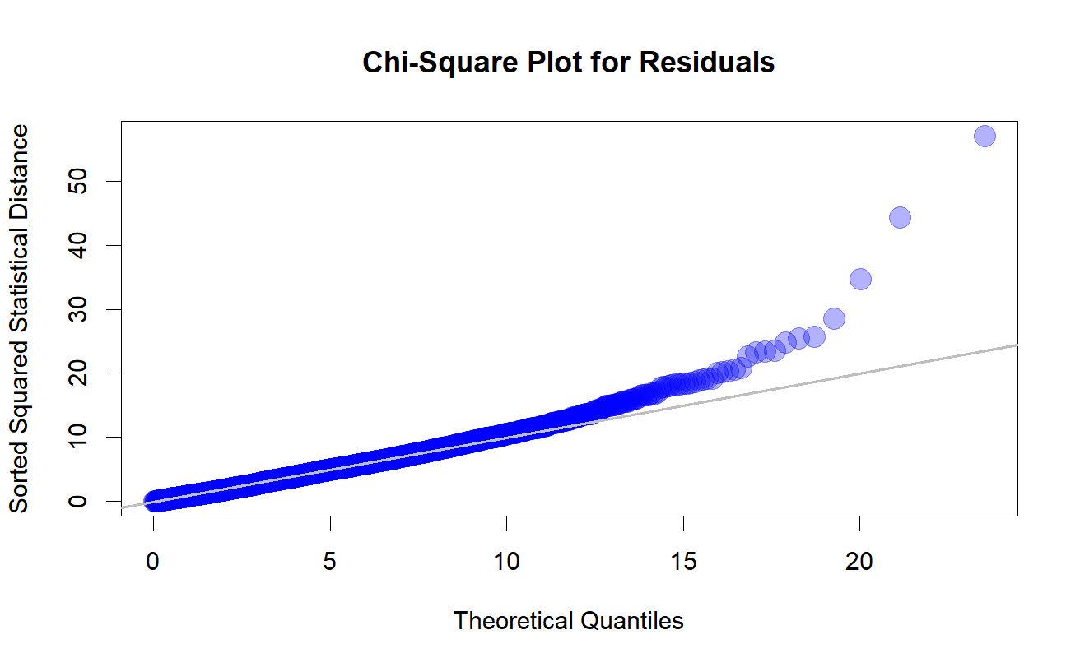

Figure 3: Final Model Homogeneity Check
